23 Editors - Toolbar
Detailed Table of Content 1
Introduction 9
Limits 9
Menus 10
(Un-) Collapse the menus 10
Toolbar Type menu 10
Toolbars Menus 11
Toolbar Settings Bforartists addon 11
Create new toolbar 11
Save Toolbar state 12
Toolbar Types 13
Toolbars File 13
Available Toolbars 13
Toolbars Mesh Edit 18
Available Toolbars 18
Toolbars Primitives 22
Available Toolbars 22
Toolbars Image 28
Available Toolbars 28
Toolbars Tools 30
Available Toolbars 30
Toolbars Animation 33
Available Toolbars 33
Toolbars Edit 36
Available Toolbars 36
Toolbars Misc 39
Available Toolbars 39

Detailed Table of Content

23 Editors - Toolbar
Detailed Table of Content 1
Introduction 9
Limits 9
Menus 10
(Un-) Collapse the menus 10
Toolbar Type menu 10
Toolbars Menus 11
Toolbar Settings Bforartists addon 11
Create new toolbar 11
Save Toolbar state 12
Toolbar Types 13
Toolbars File 13
Available Toolbars 13
Load / Save 13
Reload Startup file 13
Open Blend File 14
Recent 14
Save Blend File 14
Save As Blend File 14
Save Copy 14
Link Append 14
Link from Library 14
Append from Library 14
Import Menu 14
Export Menu 14
Import Common 15
Import FBX 15
Import Obj 15
Import ABC 15
Import Common 2 15
Import DAE 15
Import BVH 15
Import gITF2 15
Import Uncommon 15
Import STL 15
Import PLY 15
Import SVG 15
Export Common 15
Export FBX 16
Export Obj 16
Export ABC 16
Export Common 2 16
Export DAE 16
Export BVH 16
Export gITF2 16
Export Uncommon 16
Export 3DS 16
Export PLY 16
Render 16
Render Image 16
Render Animation 16
Render Open GL 17
Open GL Render Image 17
Open GL Render Animation 17
Render Misc 17
Mixdown Audio 17
Show/ Hide Renderview 17
Play rendered animation 17
Window Search 17
Toolbars Mesh Edit 18
Available Toolbars 18
Vertices Splitconnect 18
Split 18
Vertex Connect Path 18
Vertex Connect 18
Vertices Misc 18
Convex Hull 18
Blend from Shape 18
Shape Propagate 19
Edges Subdiv 19
Subdivide Edge Ring 19
Un-Subdivide 19
Edges Sharp 19
Mark Sharp 19
Unmark Sharp 19
Edges Freestyle 19
Mark Freestyle Edge 19
Unmark Freestyle Edge 19
Edges Rotate 19
Rotate 19
Edges Misc 19
Edge Split 20
Bridge Edgeloops 20
Faces general 20
Fill 20
Grid Fill 20
Beautify Faces 20
Solidify 20
Intersect 20
Boolean Intersect 20
Wire Frame 20
Faces Freestyle 20
Mark Freestyle Face 20
Unmark Freestyle Face 20
Faces Tris 21
Poke Faces 21
Triangulate Faces 21
Tris to Quads 21
Split by Edges 21
Faces Rotate Misc 21
Rotate UV's 21
Reverse UV's 21
Rotate Colors 21
Reverse Colors 21
Cleanup 21
Delete Loose 21
Decimate Geometry 21
Degenerate Dissolve 21
Make Planar Faces 22
Split Non Planar Faces 22
Split Concave Faces 22
Fill Holes 22
Toolbars Primitives 22
Available Toolbars 22
Mesh 22
Add Plane 22
Add Cube 22
Add Circle 23
Add UV Sphere 23
Add Cylinder 23
Add Cone 23
Add Torus 23
Add Grid 23
Curve 23
Add Bezier 23
Add Circle 23
Add Nurbs Curve 23
Add Nurbs Circle 23
Add Nurbs Path 23
Surface 23
Add Surface Curve 24
Add Surface Circle 24
Add Surface Patch 24
Add Surface Cylinder 24
Add Surface Sphere 24
Add Surface Torus 24
Metaball 24
Add Metaball of type Ball 24
Add Metaball of type Capsule 24
Add Metaball of type Plane 24
Add Metaball of type Elipsoid 24
Add Metaball of type Cube 24
Grease Pencil 25
Blank 25
Stroke 25
Monkey 25
Lamp 25
Add Lamp of type Point 25
Add Lamp of type Sun 25
Add Lamp of type Spot 25
Add Lamp of type Area 25
Other 25
Add Text 25
Add Armature 25
Add Lattice 26
Add Camera 26
Add Speaker 26
Empties 26
Add Empty of type Plain Axes 26
Add Empty of type Sphere 26
Add Empty of type Circle 26
Add Empty of type Cone 26
Add Empty of type Cube 26
Add Empty of type Single Arrow 26
Add Empty of type Arrows 26
Add Empty of type Image 26
Image 27
Reference Image 27
Background Image 27
Light Probe 27
Reflection Cubemap 27
Reflection Plane 27
Irradiance Volume 27
Force Field 27
Add Physics Effector of Type Boid 27
Add Physics Effector of Type Charge 27
Add Physics Effector of Type Curve Guide 27
Add Physics Effector of Type Drag 27
Add Physics Effector of Type Force 27
Add Physics Effector of Type Harmonic 28
Add Physics Effector of Type Lennard-Jones 28
Add Physics Effector of Type Magnetic 28
Add Physics Effector of Type Smoke Flow 28
Add Physics Effector of Type Texture 28
Add Physics Effector of Type Turbulence 28
Add Physics Effector of Type Vortex 28
Add Physics Effector of Type Wind 28
Collection 28
Add Collection Instance 28
Toolbars Image 28
Available Toolbars 28
UV Align 29
Align Straighten 29
Align Straighten X 29
Align Straighten Y 29
Align Auto 29
Align X 29
Align Y 29
UV Unwrap 29
Mark Seam 29
Clear Seam 29
Seams from Islands 29
Unwrap Angle Based 29
Unwrap Conformal 29
UV Modify UV 30
Pin 30
Unpin 30
Weld 30
Remove Doubles UV 30
Average Island Scale 30
Pack Island 30
Copy mirrored UV Coordinates 30
Toolbars Tools 30
Available Toolbars 30
Parent 31
Make Parent 31
Clear Parent 31
Object to Data 31
Make Single User 31
Link Data 31
Link to SCN 31
Link to SCN 31
Linked Objects 31
Make Local 31
Make Proxy 31
Join 31
Join 31
Origin 32
Set Geometry to Origin 32
Set Origin to Geometry 32
Set Origin to 3D cursor 32
Set Origin to Center of Mass 32
Set Origin to Center of Volume 32
Shading 32
Shade Smooth 32
Shade Flat 32
Data Transfer 32
Transfer Mesh Data 32
Transfer Mesh Data Layout 32
Join UV's 32
Relations 32
Make Vertex Parent 33
Toolbars Animation 33
Available Toolbars 33
Keyframes 33
Insert Keyframe Menu 33
Delete Keyframe 33
Bake Action 33
Remove Animation 33
Calculate Object Paths 34
Clear Object Paths 34
Range 34
Use Preview Range 34
Lock Frame Selection to Range 34
Frame Start 34
Frame End 34
Play 34
Current Frame 34
Jump to Endpoint 34
Jump to Keyframe 34
Play Animation 34
Play Animation 34
Jump to Keyframe 35
Jump to Endpoint 35
Sync 35
Keyframe Type 35
Keyingset 35
Use Keyframe Insert Auto 35
Keying set Dropdown box 35
Insert Keyframe 35
Delete Keyingset Keyframe 35
Toolbars Edit 36
Available Toolbars 36
Edit 36
Dissolve Vertices 36
Dissolve Edges 36
Dissolve Faces 36
Remove Doubles 36
Limited Dissolve 37
Dissolve Selection 37
Edge Collapse 37
Merge 37
Separate 37
Weigth in Edit 37
Normalize all 37
Normalize 37
Mirror 37
Invert 37
Clean 37
Quantize 37
Levels 38
Smooth 38
Limit Total 38
Fix Deforms 38
Object Apply 38
Location 38
Rotation 38
Scale 38
Rotation & Scale 38
Visual Transform 38
Make Duplicates real 38
Object Apply Deltas 38
Location 38
Rotation 39
Scale 39
All 39
Transforms to Delta Anims 39
Object Clear 39
Location 39
Rotation 39
Scale 39
Origin 39
Toolbars Misc 39
Available Toolbars 40
Undo / Redo 40
Undo 40
Redo 40
Undo History 40
Undo History 40
Repeat 40
Repeat 40
Repeat History 40
Scene 40
Adjust last Operation 41
Operator Search Menu 41
Misc 41

Introduction

The Toolbar editor is what you normally have to avoid in UI design. It's a bunch of double menu entries. It is made by lots of tools that already exists elsewhere.
But the value of this double menu here is that it is configurable. This customizable toolbar makes it possible to have the most needed tools at top UI level. This can save a ton of clicks, tabbing, scrolling, and digging in sub menus. And you can display what you need for your personal workflow. And hide away the rest.
The toolbar editor uses pure Icon buttons.
Parts of the toolbars are just visible when you are in the right mode. The full Primitives toolbar for example in just visible in Object mode. Parts of it are visible in Edit mode, dependant of what type of object you modify. And in the other modes the toolbars are hidden.
Parts of the toolbars are just visible when the right object type in the scene exists / is selected.
As told, the toolbars are double menu entries. This means te description of the tools in this chapter will be as short as possible. Closer descriptions, like how to use the tools, can be found in the other chapters where the tools comes from. The Tool Shelf in the 3D View for example.

Limits
- The toolbar does not contain all possible tools. More the opposite, the selection is very limited. Lots of tools depends to be performed in the editor type where you want to do the change. They just work there. And not in other editors. This affects for example most tools in edit mode. And the toolbar is another editor. This limits the available tools in the toolbar dramatically.
- The toolbars have a fixed order. The content is not sortable. The sorting is defined by the order of the toolbar type. And inside the toolbar type by the order in the toolbars menu. You would need to have to edit the python file to change this order.
- Just the toolbar types are independent. The checkboxes to display the toolbars themselves are global. Means when you set one toolbar type to Primitives, and activate all the primitives types there, then other toolbars with thist toolbar type will have the same primitives types displayed.
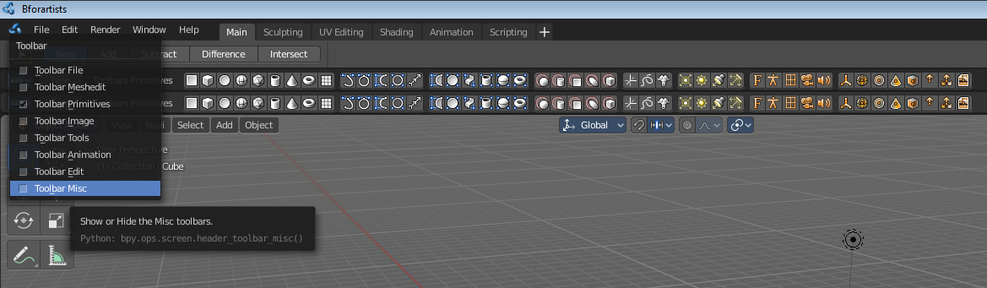

Menus

When you first look at the Toolbar then you will see no visible menus. They exists, but they are hidden away to save UI space. The text menus would eat lots of space that we can better spend in displaying more tools.

The Toolbar Type menu and the Toolbars menus are collapsed. You can expand those menus. This makes it easier to setup. But you can also work with the collapsed menus.

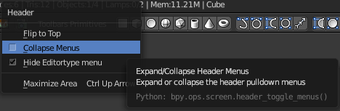
(Un-) Collapse the menus
Right click a the Toolbar. Untick Collapse Menus in the upcoming menu. Then the collapsed menus becomes visible again.
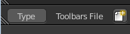

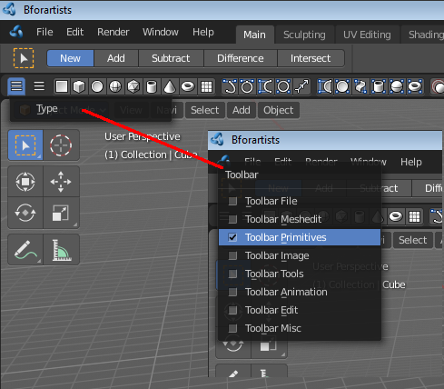
To collapse the menus go the opposite route. Right click a the Toolbar. And tick Collapse Menus in the upcoming menu.

Toolbar Type menu
The first entry of a toolbar is the Toolbar Type menu.
Choose what kind of Toolbar Type you want to show. You can show multiple types of toolbars at once.
The toolbar types are independant from each other. You can set up every toolbar to display different content.

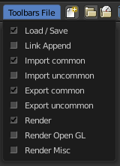
Toolbars Menus
Every toolbar type has several toolbars to display.
In the toolbar menu you can choose what toolbars you want to display.
The toolbars are not independant. This setup is global. When you for example tick the Toolbar File in this toolbar, then it will be displayed in all other toolbars too. Including in other layouts.
These checkboxes are also available in the Toolbar Settings Bforartists addon.

Toolbar Settings Bforartists addon
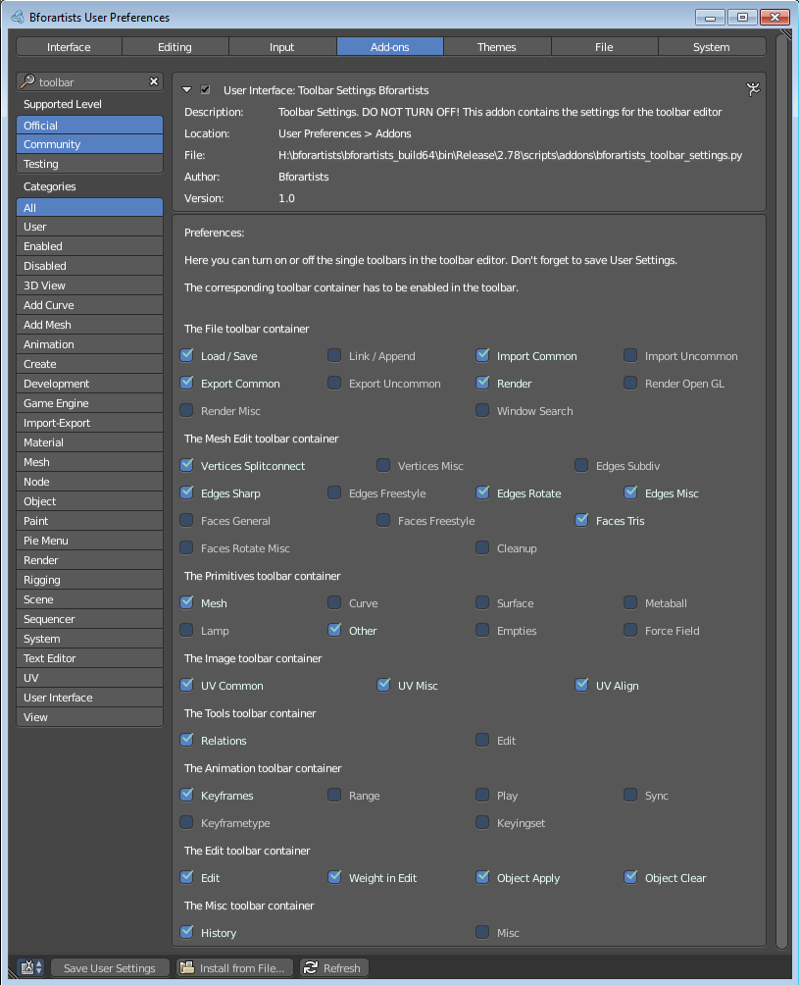
The settings for the toolbar needs to be stored somewhere. This is done in an addon called Toolbar Settings Bforartists.

This addon contains the same checkboxes than the single toolbars menus in the toolbar. But all of them at once. And here is where they get stored when you save the user settings. So when you activate some toolbars, then save the Userpreferences to make it permanent.

Warning!
Do not deactivate this addon. The toolbar will not work then. It depends of the settings in the addon!

Create new toolbar
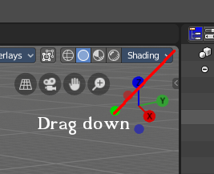
You might want to create your own toolbar for a new layout. Let's explain the needed steps.

First create a new editor type. This can be done by dragging the triangle area of an existing editor. And will create a new editor.

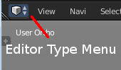
Look at the right of this new created editor type. You will now see a small button. This is the Editor type menu. Open it by clicking at it. And choose Toolbar.

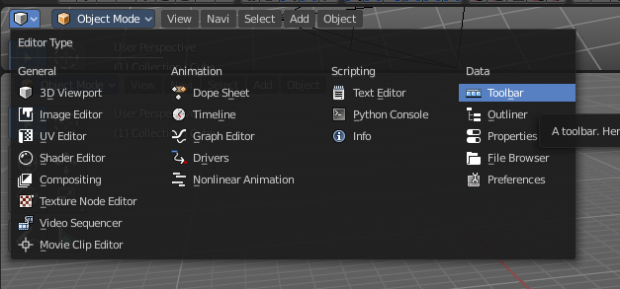

Now set up your new created Toolbar editor. Choose the toolbar types you want to display here. Then choose the toolbars to display.

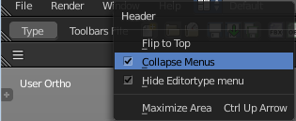
The last step is to hide the Editor Type menu and to collapse the menus. Right click at the toolbar, and tick Collapse Menus and Hide Editortype menu.

Save Toolbar state

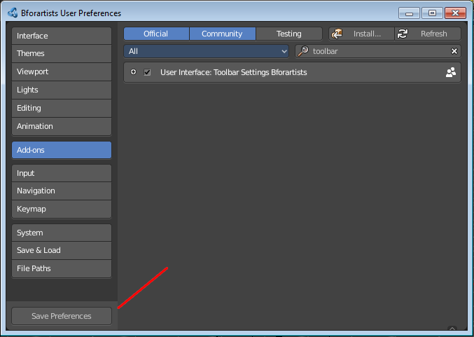
You may want to save the changes at the toolbar. Because without saving the changes you will loose them when you reopen Bforartists.

The state of the checkboxes are stored in the Toolbar Settings Bforartists Addon. So to save this part you have to save the User Settings in the User Preferences. It doesn't matter if you have changed the checkboxes in the toolbar or the addon. They are the same.

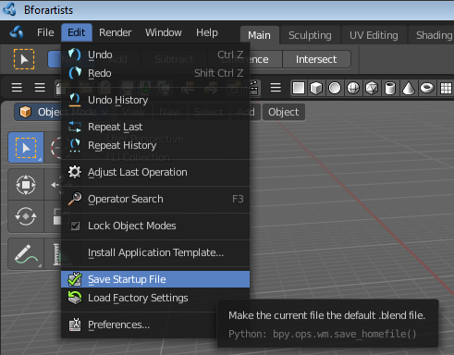
But the state of the collapsed Toolbar menus is not stored in the User Preferences. They are part of the layout. You have to save the startup file to make this changes permanent.

Be careful here. Saving the startup file saves every change at the layout. Including things like having a mesh in the scene.

Toolbar Types

Currently the Toolbar editor contains eight toolbar types.
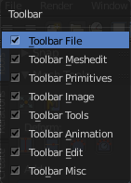
File - Contains some file menu related tools. Like load save. But also the render menu.
Mesh Edit - Contains tools for Meshes in Edit Mode.
Primitives - Contains the primitives from the Create tab in the Tool Shelf.
Image - Contains some tools for editing UV
Tools - Contains the content of the Relations panel in Object mode.
Animation - Contains Animation tools
Edit - Contains some tools from Object and Edit Mode
Misc - Contains Undo, and an empty menu as a place holder.
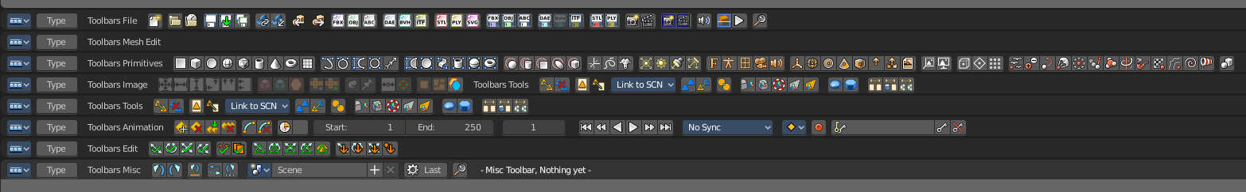

Toolbars File

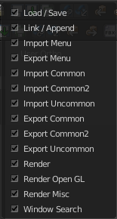
The Toolbars File contains some file menu related tools. Like load save. But also the render menu.

These toolbars are available in all modes.

Available Toolbars
The description of the single buttons goes from left to right.

Load / Save
The original menu items are in the File menu of the Info editor.

Reload Startup file
Creates a new scene.

Open Blend File
Load a Blend file.

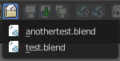
Recent
The recent files menu.

Save Blend File
Save a Blend file.

Save As Blend File
Save a Blend file as.

Save Copy
Saves a copy of the Blend file.

Link Append
The original menu items are in the File menu of the Info editor.

Link from Library
Link contend from a Blend file

Append from Library
Append content

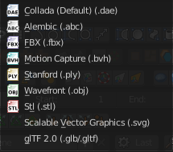
Import Menu
The Import menu is the same menu that you can find in the File menu of the Info editor. It contains all available file import types.

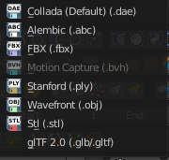
Export Menu
The Export menu is the same menu that you can find in the File menu of the Info editor.
It contains all available file export types.

Import Common
The original menu items are in the File menu of the Info editor.

Import FBX
Import FBX files.

Import Obj
Import Object files.

Import ABC
Import Alembic files.

Import Common 2
The original menu items are in the File menu of the Info editor.

Import DAE
Import Collada files.

Import BVH
Import Biovision Motion Capture files.

Import gITF2
Import gITF2 files.

Import Uncommon
The original menu items are in the File menu of the Info editor.

Import STL
Import STL files

Import PLY
Import PLY files.

Import SVG
Import SVG Files.

Export Common
The original menu items are in the File menu of the Info editor.

Export FBX
Export as FBX file.

Export Obj
Export as Obj file.

Export ABC
Export as Alembic file.

Export Common 2
The original menu items are in the File menu of the Info editor.

Export DAE
Export as Collada file.

Export BVH
Export as BVH Motion Capture file.

Export gITF2
Export as gITF2 file.

Export Uncommon
The original menu items are in the File menu of the Info editor.

Export 3DS
Export as 3DS.

Export PLY
Export as PLY file.

Render
The original menu items are in the Render menu of the Info editor.

Render Image
Renders the current scene as an image by using the current offline renderer. Either Blender Internal or Cycles.

Render Animation
Renders the current scene as an animation. Either Blender Internal or Cycles.

Render Open GL

Open GL Render Image
Renders the current scene as an image by using the Viewport and Open GL.

Open GL Render Animation
Renders the current scene as an animation by using the Viewport and Open GL.

Render Misc
The original menu items are in the Render menu of the Info editor.

Mixdown Audio
Mixdown and export the scene's audio to an audio file.

Show/ Hide Renderview
Toggles display of Render view.

Play rendered animation
Play rendered Animation sequence.

Window Search
The original menu item is in the Windows menu in the Info editor.
This button calls the search menu.
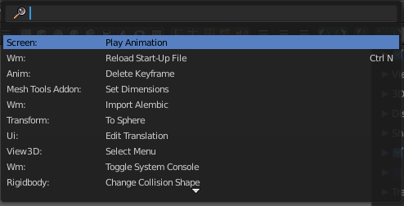

Toolbars Mesh Edit

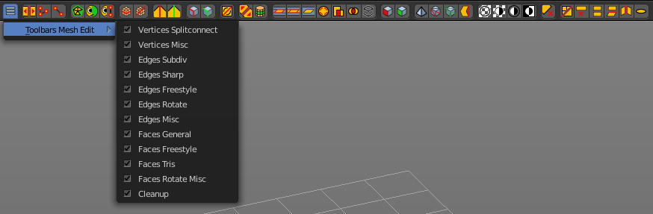
The Toolbars Mesh Edit contains tools for Mesh Objects in Edit Mode. The original menu items are mainly in the Mesh menu in Edit Mode. In the Vertices, Edges and Faces submenus.

This toolbars shows its content Edit mode.

Available Toolbars
The description of the single buttons goes from left to right.

Vertices Splitconnect

Split
Splits two connected Vertices.

Vertex Connect Path
Connect Vertices by their seleciton order, creating edges, splitting faces

Vertex Connect
Connect selected vertices of faces, splitting the face.

Vertices Misc

Convex Hull
Enclose selected vertices in a convex polyhedron.

Blend from Shape
Blend in shape from a shapekey.

Shape Propagate
Apply selected vertex locations to all other shapekeys.

Edges Subdiv

Subdivide Edge Ring
Subdivides an Edge Ring

Un-Subdivide
Unsubdivides selected edges and faces.

Edges Sharp

Mark Sharp
Mark selected edges as sharp.

Unmark Sharp
Unmark selected edges as sharp.

Edges Freestyle

Mark Freestyle Edge
Mark selected edges as Freestyle feature edges.

Unmark Freestyle Edge
Unmark selected edges as Freestyle feature edges.

Edges Rotate

Rotate
Rotate selected edges or adjoining faces.

Edges Misc

Edge Split
Split selected edges so tthat each neighbour face gets its own copy.

Bridge Edgeloops
Create faces between selected edge loops.

Faces general

Fill
Fill a selected edge loop with faces.

Grid Fill
Fill grid from two loops.

Beautify Faces
Rearrange some faces to minimize degenerations.

Solidify
Create a solid skin by extruding. Compensating for sharp angles.

Intersect
Cut an intersection into faces.

Boolean Intersect
Cut solid geometry from selected to unselected.

Wire Frame
Create a solid wire frame from faces.

Faces Freestyle

Mark Freestyle Face
Mark selected faces for exclusion from freestyle feature edge detection.

Unmark Freestyle Face
Unmark selected faces for exclusion from freestyle feature edge detection.

Faces Tris

Poke Faces
Split a face into a fan.

Triangulate Faces
Triangulates selected faces.

Tris to Quads
Join triangle faces into quads.

Split by Edges
Split faces by loose edges.

Faces Rotate Misc

Rotate UV's
Rotate UV coordinates inside faces.

Reverse UV's
Flip direction of UV coordinates inside faces.

Rotate Colors
Rotate Vertex Colors inside faces.

Reverse Colors
Flip direction of Vertex Colors inside faces.

Cleanup

Delete Loose
Delete loose vertices, edges or faces.

Decimate Geometry
Simplify geometry by collapsing edges.

Degenerate Dissolve
Dissolve zero area faces and zero length edges.

Make Planar Faces
Flatten selected faces.

Split Non Planar Faces
Split non planar faces that exceeds the angle threshold.

Split Concave Faces
Make all faces convex.

Fill Holes
Fill in holes (boundary edge loops)

Toolbars Primitives

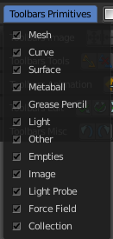
The toolbars Primitives contains the Add items from the Create tab.

The full toolbar with all its content is just available in Object mode. In other modes it hides away. Single types are also visible in Edit mode. When you work at an mesh type, then the Mesh primitives toolbar is visible for example.

Available Toolbars
The description of the single buttons goes from left to right.

Mesh
The Mesh toolbar contains the Mesh primitives.
The original menu items are in the Tool Shelf in the 3D View, in the Create tab in the Add Primitives Panel.

Add Plane
Add a Plane primitive.

Add Cube
Add a Cube primitive.

Add Circle
Add a Circle primitive.

Add UV Sphere
Add a UV Sphere primitive.

Add Cylinder
Add a Cylinder primitive.

Add Cone
Add a Cone primitive.

Add Torus
Add a Torus primitive.

Add Grid
Add a Grid primitive.

Curve
The Curve toolbar contains the Curve primitives.
The original menu items are in the Tool Shelf in the 3D View, in the Create tab in the Add Primitives Panel.

Add Bezier
Add a Bezier curve primitive.

Add Circle
Add a Circle curve primitive.

Add Nurbs Curve
Add a Nurbs Curve primitive.

Add Nurbs Circle
Add a Nurbs Circle curve primitive.

Add Nurbs Path
Add a Nurbs Path curve primitive.

Surface
The Surface toolbar contains the Surface primitives.
The original menu items are in the Tool Shelf in the 3D View, in the Create tab in the Add Primitives Panel.

Add Surface Curve
Add a Nurbs Surface curve primitive.

Add Surface Circle
Add a Nurbs Surface Circle primitive.

Add Surface Patch
Add a Nurbs Surface Patch primitive.

Add Surface Cylinder
Add a Nurbs Surface Cylinder primitive.

Add Surface Sphere
Add a Nurbs Surface Sphere primitive.

Add Surface Torus
Add a Nurbs Surface Torus primitive.

Metaball
The metaball toolbar contains the Metaball primitives.
The original menu items are in the Tool Shelf in the 3D View, in the Create tab in the Add Primitives Panel.

Add Metaball of type Ball
Add Metaball of type Ball primitive.

Add Metaball of type Capsule
Add Metaball of type Capsule primitive.

Add Metaball of type Plane
Add Metaball of type Plane primitive.

Add Metaball of type Elipsoid
Add Metaball of type Elipsoid primitive.

Add Metaball of type Cube
Add Metaball of type Cube primitive.

Grease Pencil

Blank
Inserts a blank Grease Pencil Object. A blank Grease Pencil Object has just one color

Stroke
Inserts a Stroke Grease Pencil Object. A Stroke Grease Pencil Object has a few standard colors already.

Monkey
Inserts a Monkey Grease Pencil Object. This is a grease pencil object which contains the shape of a monkey already. This monkey is a example object.

Lamp
The Lamp toolbar contains the different lamp types.
The original menu items are in the Tool Shelf in the 3D View, in the Create tab in the Add Misc Panel.

Add Lamp of type Point
Add Lamp of type Point.

Add Lamp of type Sun
Add Lamp of type Sun.

Add Lamp of type Spot
Add Lamp of type Spot.

Add Lamp of type Area
Add Lamp of type Area.

Other
The Other toolbar contains some other ground types like bones and text.
The original menu items are in the Tool Shelf in the 3D View, in the Create tab in the Add Misc Panel.

Add Text
Add a Text object.

Add Armature
Add a Armature object.

Add Lattice
Add a Lattice object.

Add Camera
Add a Camera object.

Add Speaker
Add a Speaker object.

Empties
The Empties toolbar contains the available empty types.
The original menu items are in the Tool Shelf in the 3D View, in the Create tab in the Add Misc Panel.

Add Empty of type Plain Axes
Add Empty of type Plain Axes.

Add Empty of type Sphere
Add Empty of type Sphere.

Add Empty of type Circle
Add Empty of type Circle.

Add Empty of type Cone
Add Empty of type Cone.

Add Empty of type Cube
Add Empty of type Cube.

Add Empty of type Single Arrow
Add Empty of type Single Arrow.

Add Empty of type Arrows
Add Empty of type Arrows.

Add Empty of type Image
Add Empty of type Image.

Image

Reference Image
Creates a plane with an image that can be used as a reference image.

Background Image
Creates a plane with an image that can be used as a Background image.

Light Probe

Reflection Cubemap
Creates a lightprobe with a reflection cubemap.

Reflection Plane
Creates a lightprobe with a reflection plane.

Irradiance Volume
Creates a lightprobe with Irradiance Volume.

Force Field
The Force Field toolbar contains the available Force field types.
The original menu items are in the Tool Shelf in the 3D View, in the Create tab in the Add Misc Panel.

Add Physics Effector of Type Boid
Add Physics Effector of Type Boid.

Add Physics Effector of Type Charge
Add Physics Effector of Type Charge.

Add Physics Effector of Type Curve Guide
Add Physics Effector of Type Curve Guide.

Add Physics Effector of Type Drag
Add Physics Effector of Type Drag.

Add Physics Effector of Type Force
Add Physics Effector of Type Force.

Add Physics Effector of Type Harmonic
Add Physics Effector of Type Harmonic.

Add Physics Effector of Type Lennard-Jones
Add Physics Effector of Type Lennard-Jones.

Add Physics Effector of Type Magnetic
Add Physics Effector of Type Magnetic.

Add Physics Effector of Type Smoke Flow
Add Physics Effector of Type Smoke Flow.

Add Physics Effector of Type Texture
Add Physics Effector of Type Texture.

Add Physics Effector of Type Turbulence
Add Physics Effector of Type Turbulence.

Add Physics Effector of Type Vortex
Add Physics Effector of Type Vortex.

Add Physics Effector of Type Wind
Add Physics Effector of Type Wind.

Collection

Add Collection Instance
Add a collection instance.

Toolbars Image

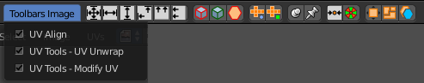
The toolbars Image contains some image related tools. At the moment this toolbar contains just tools to edit UV meshes. This means that you have to be in Edit mode with an UV mapped mesh to make the tools active.
The original menu items are in the Image menu of the UV Image Editor.

Available Toolbars
The description of the single buttons goes from left to right.

UV Align
The UV Align toolbar contains tools to clean up and align the selected UV geometry.

Align Straighten
Align UV's along the line defined by the end points of the selection.

Align Straighten X
Align UV's along the line defined by the end points along the X axis.

Align Straighten Y
Align UV's along the line defined by the end points along the Y axis.

Align Auto
Automatically choose the axis on which there is most alignmend already.

Align X
Align UV's at X axis

Align Y
Align UV's at Y axis

UV Unwrap
The UV Common toolbar contains tools for unwrapping.

Mark Seam
Mark selected UV Edges as Seam.

Clear Seam
Remove Seam from selected UV Edges.

Seams from Islands
Marks the border edges of the UV patches as Seam.

Unwrap Angle Based
Unwraps the selected geometry with the Angle based ( ABF ) method.

Unwrap Conformal
Unwraps the selected geometry with the Conformal ( LSCM ) method.

UV Modify UV
The UV Modify toolbar contains tools to clean up the uv mapping.

Pin
Pins the selected vertices.

Unpin
Unpins the selected verstices.

Weld
Weld the selected UV vertices together.

Remove Doubles UV
Removes double vertices

Average Island Scale
Average the size of separated UV patches, based at their size in 3D space.

Pack Island
Packs the UV patches so that they fit best into the UV space, and as few texturespace as possible is wasted.

Copy mirrored UV Coordinates
Copy mirrored UV Coordinates at X axis based on a mirrored mesh.

Toolbars Tools

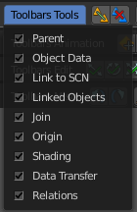
The Toolbars Tools contains some tools in object mode. The content from the relations panel and the edit panel in the tool shelf. And one tool in Edit mode. Make Vertex Parent. Since this is also part of the relations panel.

Available Toolbars
The description of the single buttons goes from left to right.

Parent

Make Parent
Parents the selected object to the active object.

Clear Parent
Removes the parenting.

Object to Data

Make Single User
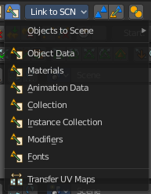
Make linked data local to each object.

Link Data
Apply active object links to other selected objects.
This button is a menu wChoose the link method.

Link to SCN

Link to SCN
Link selection to another scene. This other scene has of course to exist.

Linked Objects

Make Local
Make library linked datablocks local to this file.

Make Proxy
Add empty object to become local replacement data of a library linked object.

Join

Join
Join selected objects into active objects.

Origin

Set Geometry to Origin
Sets the geometry to origín.

Set Origin to Geometry
Sets the origin to geometry.

Set Origin to 3D cursor
Sets the origin to the 3D cursor.

Set Origin to Center of Mass
Sets the origin to the center of mass.

Set Origin to Center of Volume
Sets the origin to the center of volume.

Shading

Shade Smooth
Shades the geometry smooth.

Shade Flat
Shades the geometry flat.

Data Transfer

Transfer Mesh Data
Transfers mesh data.

Transfer Mesh Data Layout
Transfers the mesh data layout.

Join UV's
Transfer UV Maps.

Relations
The Relations toolbar contains one tool in Edit mode. Make Vertex Parent.

Make Vertex Parent
Parents an object to the selected vertice(s).

Toolbars Animation

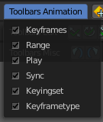
The Toolbars Animation contains tools around animation. The Toolbars Range, Play, Sync and Keyingset are the toolbars from the Timeline. But separated into four independant parts.

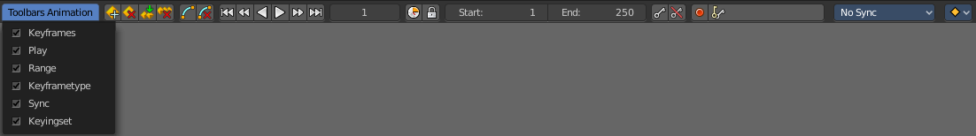

Available Toolbars
The description of the single buttons goes from left to right.

Keyframes
The Keyframes toolbar contains some keyframe tools. The original menu items can be found in the Tool Shelf in the Animation tab in the Animation panel.
The original menu items are in the Tool Shelf in the 3D View, in the Animation tab in the Animation panel.

Insert Keyframe Menu
When there is no keying set assigned to the currently selected object ,then this button is a menu wChoose a keying set. When there is already a keying set assigned, then you can record a keyframe with this button

Delete Keyframe
Deletes the current Keyframe

Bake Action
Bakes the animation to a new action

Remove Animation
Remove all keyframe animation for selected objects

Calculate Object Paths
Calculate motion paths for the selected objects.

Clear Object Paths
Clears motion paths for the selected objects.

Play

Jump to Endpoint
Jumps to beginning of animation

Jump to Keyframe
Jumps to the previous keyframe Play Animation

Play Animation
Plays animation reversed

Play Animation
Plays animation forward

Jump to Keyframe
Jumps to next keyframe

Jump to Endpoint
Jumps to end of animation

Current Frame
The current frame number

Range

Use Preview Range
Use an alternative start/end frame grange for animation playback and OpenGL renders instead of the Render Properties start/end frame range.

Lock Frame Selection to Range
Don't allow frame to be selected with mouse outside of frame range

Frame Start
The frame start point

Frame End
The frame end point

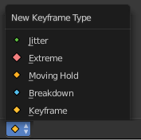
Keyframe Type
Keyframe Type is a dropdown box wChoose in what color the keyframe gets displayed in the Dope Sheet Editor.

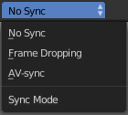
Sync
Sync is a dropdown box where you can adjust the syncing method.

Keyingset

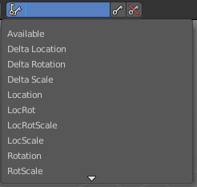
Insert Keyframe
Insert a keyframe.

Delete Keyingset Keyframe
Delete Keyframe.

Use Keyframe Insert Auto
Auto insert keyframes at manipulation.

Keying set Dropdown box
This is a dropdown box wChoose the keyingset method.

Toolbars Edit

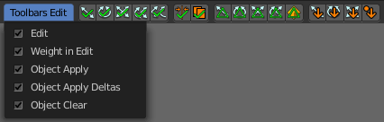
The Toolbars Edit contains various toolbars around editing. Some content just shows when an object exists in the scene. Some content is visible in Object mode. Some content is visible in Edit mode.

Available Toolbars
The description of the single buttons goes from left to right.

Edit
The Edit toolbar is just visible in Edit Mode. The original menu items are in the Tool Shelf in the 3D View in the Tools tab in the Mesh Tools panel.

Dissolve Vertices
Dissolve Vertices.

Dissolve Edges
Dissolve Edges.

Dissolve Faces
Dissolve Faces.

Remove Doubles
Removes double vertices.

Limited Dissolve
Dissolve Edges and Vertices limited by the surrounding angle.

Dissolve Selection
Dissolve Geometry dependant of selection mode.

Edge Collapse
Collapse selected edges.

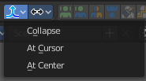
Merge
Merges selected geometry. This is a dropdown box wChoose where to merge.

Separate
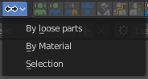
Separate the selection, and create a new object from it. This is a dropdown box wChoose the separate method.

Weigth in Edit
The Weight in Edit toolbar is just visible in Edit Mode for normal meshes, and Pose mode when you have a rigged character selected. The original menu items are in the Tool Shelf in the 3D View in the Tools tab in the Weight Tools panel. You need to have a Vertex Group applied.

Normalize all
Normalizes the whole mesh.

Normalize
Normalizes the selection

Mirror
Mirrors the selection.

Invert
Inverts the weighting.

Clean
Remove Vertex Assignments that are not required.

Quantize
Set Weights to a fixed number of steps.

Levels
Add some offset and multiply with some gain the weights of the active vertex group.

Smooth
Smooth weights for selected vertices.

Limit Total
Limit deform weights.

Fix Deforms
Fix Deforms by modifying the position of selected vertices.

Object Apply
The Object Apply toolbar is just visible in Object Mode. The original menu items are in the Object menu in the 3D View. The Apply menu.

Apply Location
Apply location.

Apply Rotation
Apply Rotation.

Apply Scale
Apply Scale.

Apply All
Apply Location, Rotation, Scale.

Apply Rotation & Scale
Apply Rotation, Scale.

Apply Visual Transform
Apply Visual Transform.

Apply Make Duplicates real
Make Duplicates attached to this object real.

Object Apply Deltas
Object Apply deltas converts normal object transforms to delta transforms. Any existing delta transform will also be included.

Location
Apply location.

Rotation
Apply Rotation.

Scale
Apply Scale.

All
Apply Location, Rotation, Scale.

Transforms to Delta Anims
Convert object animation for normal transforms to delta transforms

Object Clear
The Object Clear toolbar is just visible in Object Mode. The original menu items are in the Object menu in the 3D View. The Clear menu.

Location
Resets the position of the object to zero

Rotation
Resets the object's rotation to zero

Scale
Resets the object's scale to 1

Origin
Resets the Origin Position

Toolbars Misc

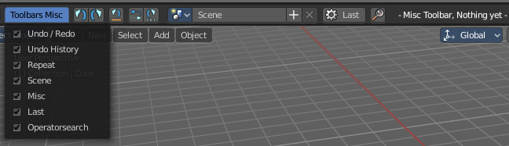
The Toolbars Misc contains some miscellaneous tools. Undo, the Scene dropdown box, Last Operator and Operator Search.

Available Toolbars
The description of the single buttons goes from left to right.

Undo / Redo

Undo
Undo the last step

Redo
Redo the last undone step

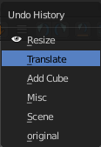
Undo History

Undo History
A click at at the button reveals a list of the last operations where you can undo more than one step.

Repeat

Repeat
Repeats the last action

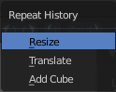
Repeat History
A click at at the button reveals a list of the last operations wChoose from wich undo step to repeat.

Scene
The Scene dropdown box to choose and create a new scene data block. The original dropdown box is in the Properties editor in the Scene tab in the Scene panel.

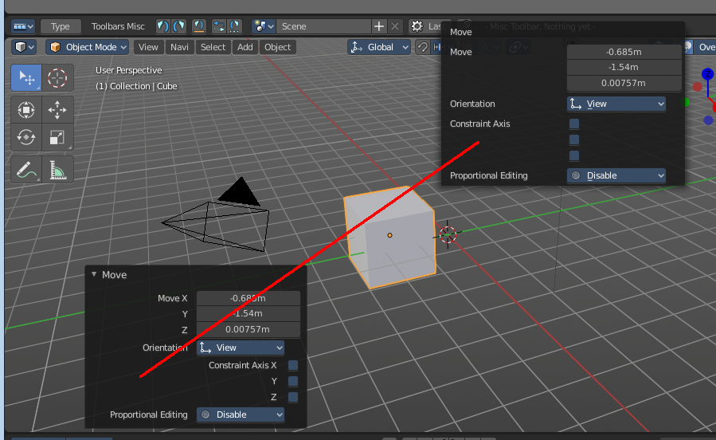
Adjust last Operation
Adjust the latest operation. This is the same panel than the one in the 3D view down left. At least when it comes to content.

Operator Search Menu
The original menu item is in the header in the Edit menu.
This button calls the Operator search menu.

Misc
The Misc toolbar is currently empty besides a placeholder string.

